

Spring Term 2026: 1st half term
Dear year 3 parents and carers,
Happy New Year! We hope you that you have had a restful break. This term we welcome Mr Lumsden to our Year 3 team, as the new class teacher in 3 Cameron. We have outlined our curriculum plan for spring half term 1, below:

Reading
This half term Hockney class are reading George’s Marvellous Medicine and Cameron class are reading the The BFG. Within our reading lessons, we will continue to practise using different reading strategies, such as clarifying, inferring, making connections, evaluating, summarising predicting and asking questions about our focused texts. The children also complete written comprehension tasks each week.

Library
Due to Forest School, our library days have changed for the spring term. Cameron class will visit the library on Mondays and Hockney on Fridays.

Writing
Our Talk for Writing unit this half term will focus around Portal stories. Our model text is Elf Road. We will be looking at the language and structural features of portal stories and incorporating these into our writing. The children will also focus on setting descriptions within their writing, focusing on the use of adjectives, carefully chosen verbs and adverbs, as well as prepositions.

Maths
Our maths units for this half term are, Multiplication and Division and then Measurement: Length and
Perimeter. During the multiplication and division unit, the children will learn about related calculations, as well as multiplying a two-digit number. We will continue to practise our arithmetic skills on Wednesdays.

Forest School
Excitingly, this term the year 3 children will be attending Forest School sessions with our forest school teacher. They will be venturing out to Alexandra Palace and exploring the woodland. Hockney will be on Mondays and Cameron on Tuesdays. Please ensure your child has warm and waterproof clothes with them, as well as a change of socks and shoes for when they get back to school.

Religious Education
For the spring term, we will be learning about Christianity. This half term we are finding out about
Jesus' miracles. Our “big question” for this unit is: Could Jesus heal people? Were these miracles or is there some other explanation?

Physical Education
This half term, our PE focus is Dance. We are learning to perform dance actions with greater control, fluency and co-ordination. Hockney class will have swimming lessons on Thursdays and PE on
Tuesdays. Cameron class will have PE on Mondays and Thursdays. Please note the information about PE kits below.

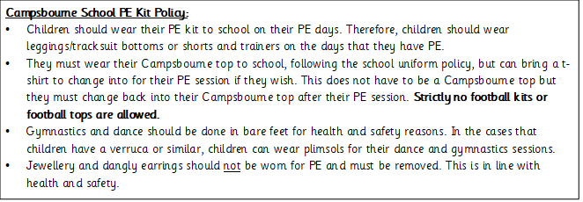

PSHE
Our PSHE unit is Healthy and Safer Lifestyles: Managing Risk. This unit of work will be taught through Forest School sessions, as well as circle times at school. The children will be introduced to the concepts of risk management in real life situations. They will develop their understanding of ways in which risks might be assessed and reduced.

Science
Over the course of this half term, we will be studying Fossils and Soils. During this unit, the children will be exploring fossils and finding out how they are formed. They will then explore soil and learn about its importance. The children will plan, carry out and evaluate an investigation into the absorbency of different types of soils.

Computing
This half term, the children will explore the concept of sequencing in programming through Scratch. The unit begins with an introduction to the programming environment and children will be introduced to a selection of motion, sound, and event blocks which they will use to create their own programs, featuring sequences. The final project is to make a representation of a piano.

Supporting at home
- Accelerated Reader – the children have been given a colour band of books which are appropriate for their level of comprehension. Please can you encourage your child to read as much as possible at home – this can be out loud, by themselves as well as listening to you read to them. We really want to encourage a love of reading! Children should try to complete an AR quiz after they have finished each book.
- Spelling and handwriting – please encourage your child to practise their spellings (with the correct joined letter formation). It is important that they are not only able to learn the words for a spelling test, but that they are also using the correct spelling when writing the words in sentences.
- Maths – Children should be regularly practising their times tables and quick recall of known facts (e.g. halving/doubling, number bonds (to 10/to 20/ to 100). Little and often is key!
We look forward to continuing to work with you over the course of the spring term and appreciate your ongoing support. Any questions or queries, please speak to your child’s class teacher.

Kind regards,
Jenny Vincent and Mr Lumsden

